- IDA, UGLY, DRAKE (facilitator to play Beaky)
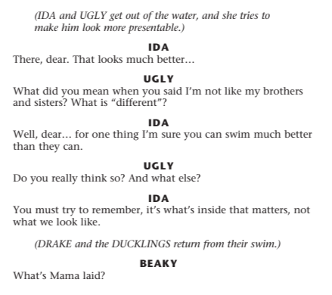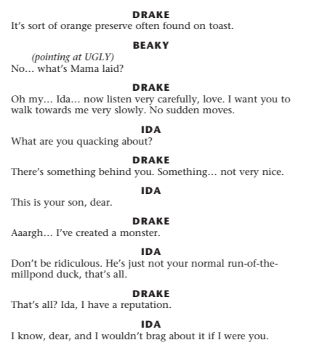
- GRACE, IDA, DRAKE (Facilitator to play to Turkey)
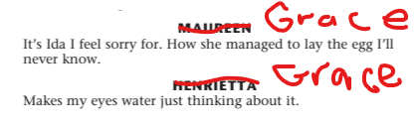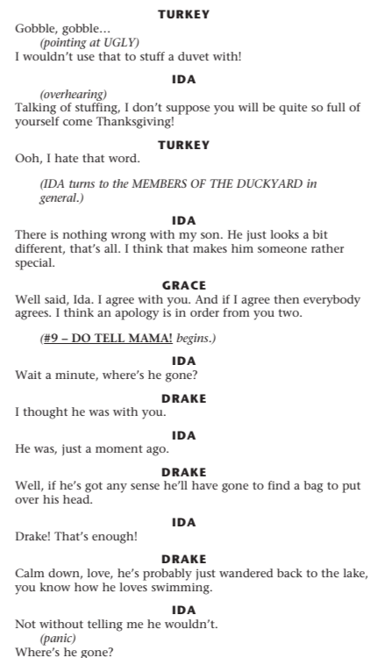
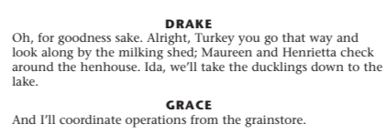
- GREYLAG, DOT, UGLY
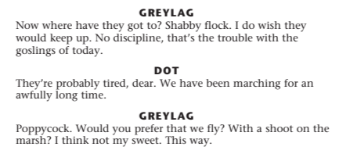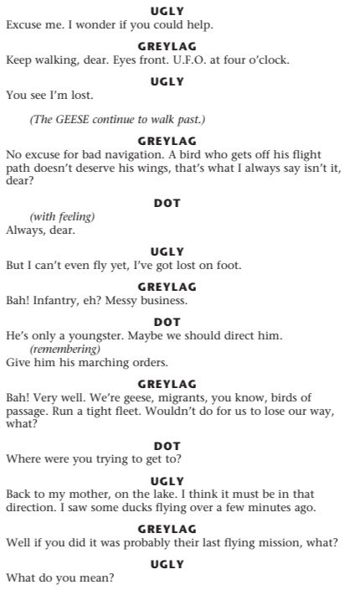
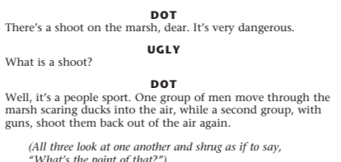
- CAT, GREYLAG, UGLY (Facilitator to play Snowy)
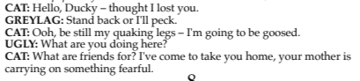
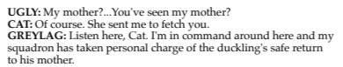
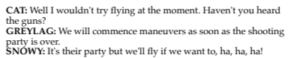
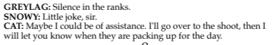
Greylag: Very well but no funny business. I know several ways to skin your type!
Cat (aside): Its like taking candy from a baby

- DRAKE, FLUFF, BEAKY, DOWNY
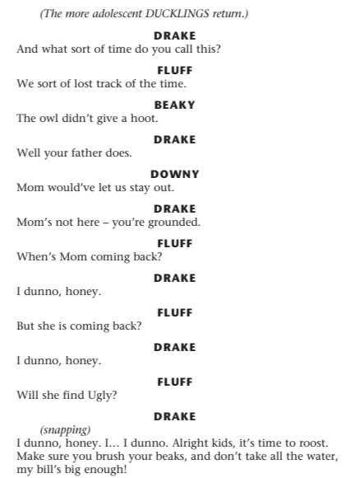

- IDA, BILLY, FLUFF, BEAKY, DOWNY, Maureen (To be played by facilitator)
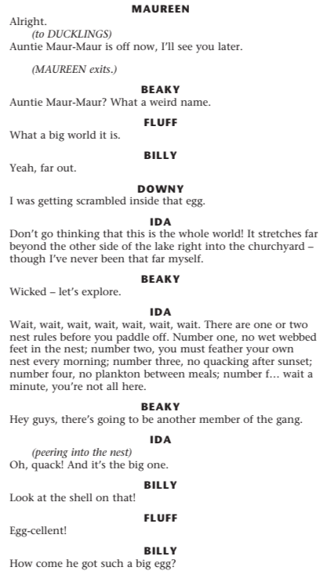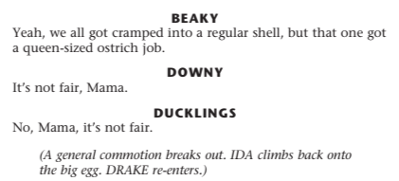
7a. Monologue – DOT
Good afternoon ladies and gentlemen. My name is Dot.

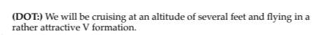
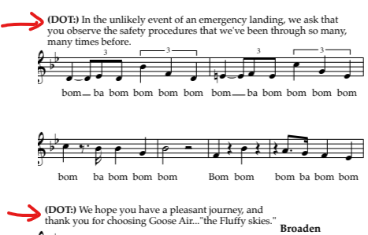
7b. MONOLGOGUE – Jay Bird
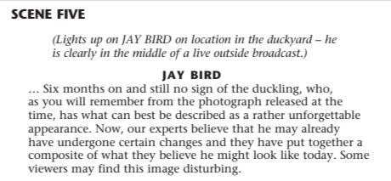

- MONOLOGUE – BULL FROG
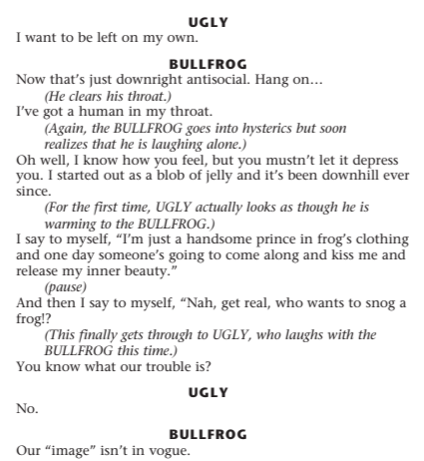

- IDA / DRAKE Reading
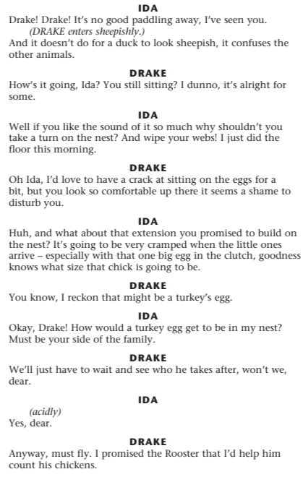

- MAUREEN / IDA Reading
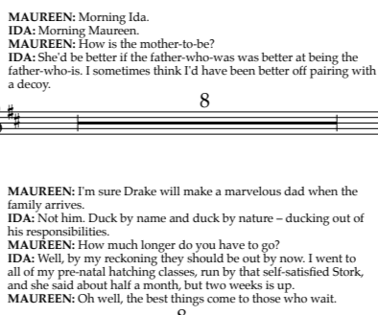
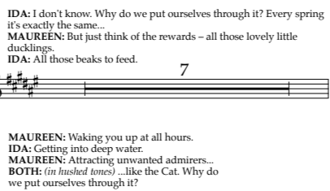

- CAT / UGLY Reading
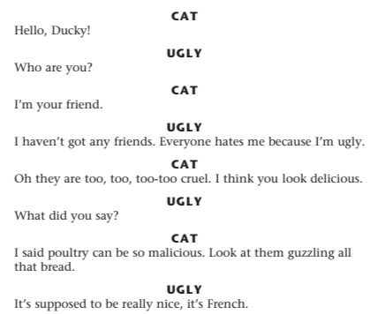
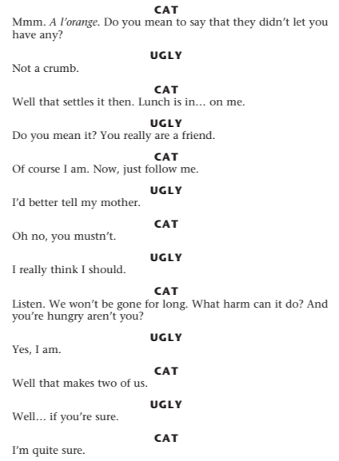
- IDA / UGLY Reading

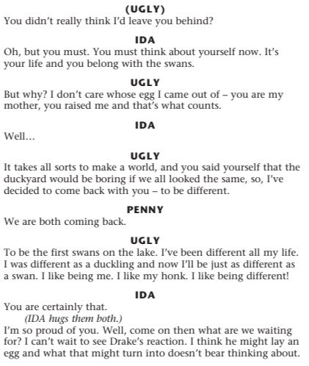

- LYRICS - A POULTRY TALE
Page 3 to 6
Bars 30 to 56

There's a turkey with a gobble
Watch his legs begin to wobble
‘Cause Thanksgiving gives him cause for some alarm
We've got pullets. We've got chickens.
We've got quails and what the Dickens
It's a poultry tale
Of folk down on the farm

What a gorgeous vision this is
It's Ida. She's my missus
So forgive me if I'm laying on the smarm.
She goes in for heated quacking
To point out the skills I'm lacking
It's a poultry tale
Of folks down on the farm!

Come on down and don't be strangers
In our duckyard of free rangers
It's a poultry tale
Of folk down on the farm!

- LYRICS – THE JOY OF MOTHERHOOD
Pages 16 to 19 Bars 0 to 50
As a duck
When you're stuck
Sat sitting in the middle of your nest
Then at best you get bored
There goes Drake
On the lake
I can see him through the rushes
All the time
Feeling I'm
Just ignored
I don't pretend that this is all he's doing
I'm a sucker for the billing and the cooing
But when you hear that pitter patter
Of tiny feet it doesn't matter
How long I've had to sit here minding my brood
Those little heads so soft and downy
Their baby bods, all gold and browny
The beaks constantly open waiting for food

It's the joy of motherhood
Those little ducklings walking round in a line
I'll do what any other mother would
To try to do my best at bringing up mine
It's the joy of motherhood
Those little perks that make it all seem worthwhile
I'll do what any other mother would
To get my ducks decked out and living in style
- LYRICS – DIFFERENT
Page 49 52
Bars 0 31

If they knew just how dearly I would love to qua… ONK.
But it's true. I'm a bird who seems to lack the knack

I'm just different
I'm just different from the rest
And who can blame them wanting me to find another nest
But different isn't naughty, different isn't bad
Why should being different make me sad

I'm just different
They're like peas from the same pod
No wonder they make fun of me
Life's harder when you're odd
But different isn't scary , Different is no threat
And though I'm still their brother they forget

I didn't choose to look this way
I didn't want to be unique
I don't like these grubby feathers and I hate my stubby beak
There's a runt in every litter
One black sheep in every flock
But when you know it's you, somehow your ego takes a knock

- LYRICS – PLAY WITH YOUR FOOD
Page 57 to 59
Bars 0 to to

You can scratch the antique furniture
To sharpen up your claws
You can lacerate the cushions
If you're ever stuck indoors
You can dig up all the flowers
From the freshly planted beds
And with articles of clothing
It's okay to pull some threads

But I remember as a kindergarten kitten
One phrase that left me singularly smitten

You can play with your food before you eat it
You can chivvy your child before you chew
You can play with your food, you can't beat it
So ducky let me be play with you.

You can play with your food before you bite it
You can toy with your tuck before the crunch
You can play with your food, Why fight it?
It's a crazy little game called lunch!

- LYRICS – WARTS AND ALL

Out there
(Somewhere out there)
Someone's going to love ya
(We don't know where)
Someone's going to love ya
(Someone will care)
Warts and all
(They're going to love ya warts and all)

Out there
(Somewhere out there)
In a muddy puddle
(We can’t say where or...)
Someone needs a cuddle
(...when though)
Though the chance is small
(The chance is small..)

It's true

Just think
Whenever you need boosting
One day
You'll be roosting
With a mate
(Soon you’ll be roosting)
Though it
May take some time to find ‘em
When you do you'll have a ball
(We know you’re gonna have a ball)

Out there somewhere
Someone's going to love you
Warts and all (x 3)

