

Spamalot
Audition Pack 2022

Director: Lloyd McDonald
Choreographer: Ash Howes
Producer / Musical Director: Ruth Myers

Key Dates

Auditions

Thursday 21st July AND Monday 25th July 6.00 -8.00pm
Solo auditions for main roles Thursday 28th July (Booking required)
CWA Hall, 56 Wason Street, Milton

Rehearsals

Rehearsals will be Monday and Thursdays 6.00 – 8.00pm starting August 1st and will continue through to performance dates. Not everyone will be required for every rehearsal. There will be some flexibility through the schedule, so please let us know any rehearsals that you are unavailable for as soon as possible.

Rehearsals WILL continue through the Sept / October school holidays for cast members that are available.

There will be additional rehearsals/requirements on the following dates:

Friday 4th November: Bump In
Saturday 5th November: Technical Run (Crew + Selected Cast only)
Sunday 6th November: Full Day Dress Rehearsal
Monday 7th November: Evening Dress Rehearsal
Thursday 10th November: Evening Dress Rehearsal

Performances

Friday 11th November 7pm: Opening Night
Saturday 12th November7pm Evening Performance
Sunday 13th November 2pm: Matinee Performance

Friday 18th November 7pm: Evening Performance
Saturday 19th November 7pm: Evening Performance
Sunday 20th November 2pm: Matinee Performance + Bump Out + After Show Party

All cast members are required to be available for ALL dress rehearsals and performances.

Show Synopsis

Lovingly ripped off from the classic film comedy Monty Python and the Holy Grail, MONTY PYTHON’S SPAMALOT retells the legend of King Arthur and his Knights of the Round Table, and features coconuts and imaginary horses, not to mention cows, killer rabbits, and French people. The 2005 Broadway production won three Tony® Awards, including Best Musical, and was followed by two successful West End runs. The outrageous, uproarious, and gloriously entertaining story of King Arthur and the Lady of the Lake will delight audiences as they search for the Holy Grail and “always look on the bright side of life.”

The Characters

Please note: Roles in Spamalot are open to all genders except for the roles of King Arthur (male identifying), Sir Lancelot (male identifying) and The Lady of the Lake (female identifying).

• KING ARTHUR - The King of England who sets out on a quest to form the Knights of the Round Table and find the Holy Grail. Good singer.
• THE LADY OF THE LAKE - A Diva. Strong, beautiful, possesses mystical powers. The leading lady of the show. Great singing voice essential, as she has several big solos.
• SIR ROBIN - A Knight of the Round Table. Ironically called 'Sir Robin the Brave,' though he couldn't be more cowardly.
• SIR LANCELOT - A Knight of the Round Table. He is fearless to the point of lunacy.
• PATSY - King Arthur's horse and servant. Underappreciated but always longing for King Arthur's approval. Strong comedic performer required.
• SIR GALAHAD - A Knight of the Round Table. Begins as Dennis, a lower class 'mud gatherer' who becomes knighted and transforms into the dashing Sir Galahad.
• SIR BEDEVERE - A Knight of the Round Table. An inept scholar. No solo singing.
• HISTORIANS x 3- Tweedy academics. Must have excellent diction.
• NOT DEAD FRED - A sickly little fellow who, despite others' beliefs, claims he is "not yet dead."
• SINGING MAYOR and FINLAND VILLAGERS
• SINGING MONKS
• DENNIS GALAHAD'S MOTHER - A shrill peasant woman
• THE FRENCH TAUNTER - An arrogant, condescending, over-the-top Frenchman.
• TWO FRENCH GUARDS - Also arrogant, condescending, over-the-top Frenchmen.
• ROBIN'S MINSTRELS - In Sir Robin's band.
• THE BLACK KNIGHT – A “never say die” warrior knight
• THE KNIGHT OF NI - An absurd and peculiar group of Knights.
• TIM THE ENCHANTER - A Ghostly being with a Scottish accent.
• SIR BORS - A Knight who will confront the killer rabbit.

Who can audition?

This is the Milton Follies Youth Production. We are looking to encourage and develop young performers from age 8 to 25. We are willing to consider younger performers with parental support.

Audition Information

We want everyone to come to both audition workshop dates on Thursday 21st July AND Monday 25th July. There are multiple speaking and singing roles in this show so we need to see what everybody can do!

We will be playing theatre games and workshopping some of the scenes from the show (examples are attached to the end of this document)

We will also be asking everyone to sing “Happy Birthday”, “Advance Australia Fair” or “Let It Go” from Frozen to assess your singing voice. (If there is another song you would like to perform, please bring your own backing track and phone / speaker to perform with.)

We will also spend some time teaching you some simple moves (think box step / grapevine / jazz hands) to see who we can use as a featured dancer. There will be NO solo dancing at these audition workshops

Casting for leading roles will be on Thursday 28th July. If you would like to audition for a major role, you will need to book a ten minute audition slot on this date. You will be asked to perform a song solo and workshop some lines solo with the casting panel. If you are happy to be considered for ensemble / featured ensemble roles only, you do not have attend on this date.

What To Bring To Your Audition

- Comfortable clothes for dancing
- Covered shoes for dancing (No thongs, sandals OR bare feet.)
- Water bottle
- Your completed audition form (see end of Audition pack)
- A small head and shoulder photo attached to your audition form
- MOST IMPORTANT – A FUN POSITIVE ATTITUDE!

Additional Show Information

We are still finalising our show pack. At this stage, we anticipate that the show fee will be $100. Milton Follies is a Creative Kids Provider, so your voucher – if not already used – can be used for this show.

We will be asking performers to purchase their own makeup, including foundation, lipstick, mascara and eyeliner.

Most costumes for this show will be provided by Milton Follies. We will be asking you to provide your own footwear.

You will be provided with a show T-Shirt.

If you are experiencing financial hardship, please let our production team know and we will do our best to assist.

We will be asking for family volunteers to assist during show weeks. Front of house roles include usher, canteen duty, raffle and ticket sales. Sound and lighting roles include sound and light desk, spotlight operators and head microphone wrangling. Back stage roles include stage hands, hair and makeup artists and den parents. A roster will be drawn up closer to show week.

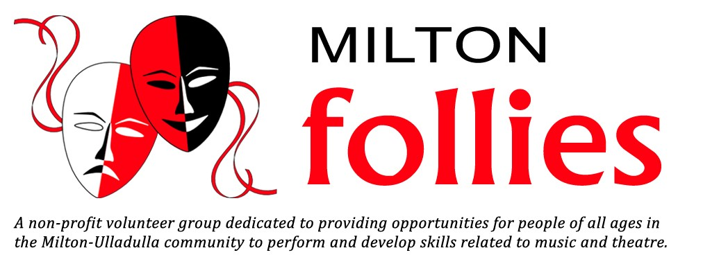
Photo

AUDITION FORM for Spamalot 2022

Name:______________________________________________________________________________

Age: _______________________________________________________________________________

Contact Number:______________________________________________________________________

If under 18, name and contact number of parent / guardian: ____________________________________

____________________________________________________________________________________

Facebook User Name (Must be 13+):______________________________________________________

Contact Email Address: _________________________________________________________________

Special Needs: (Allergies, Medical Conditions, Medication etc we should be aware of):

____________________________________________________________________________________

Briefly list your performing experience, eg, dance, voice, instrument, acting.

____________________________________________________________________________________

____________________________________________________________________________________

____________________________________________________________________________________

If you would like to audition for a particular role, please let us know which one.

Sample Script 1

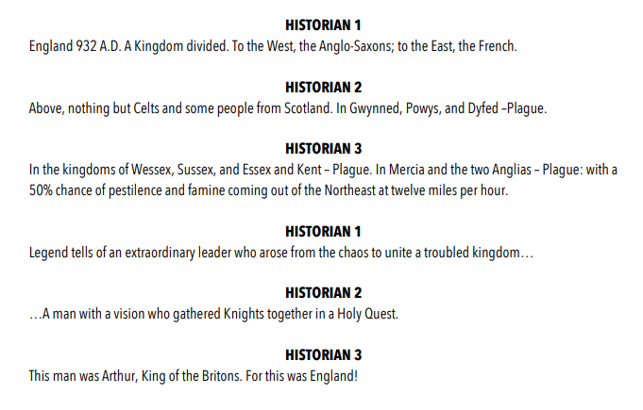

Sample Script 2
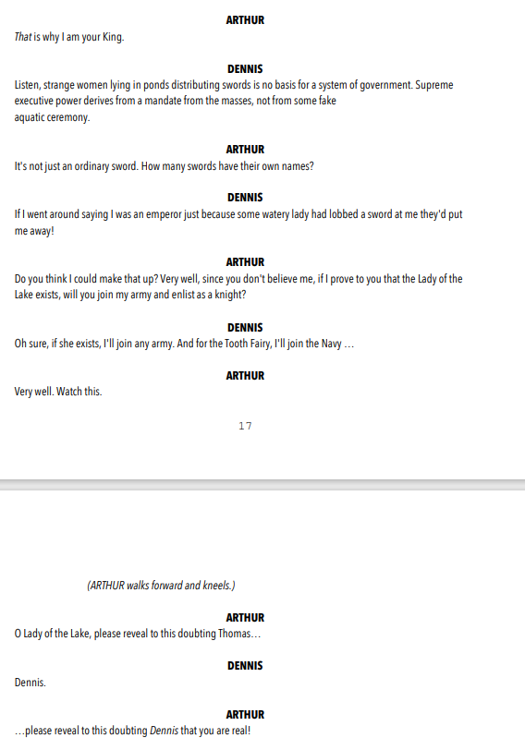

Sample Script 3

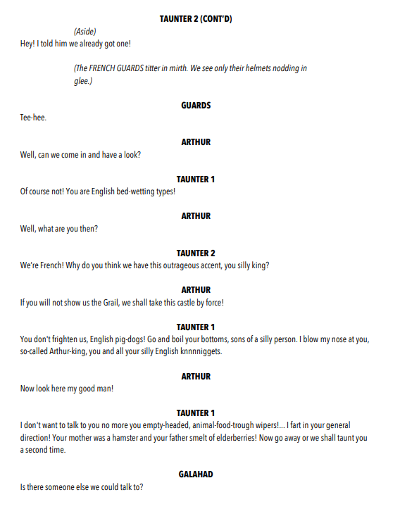

Sample Script 4

